Implementation of 2-D Voronoi Diagrams & Delaunay Triangulation

# Program Outline:-

## Remark:-

The asymptotic complexity of this straight forward method was O (n^4) which is bad compared to other algorithms discussed. They have a complexity ranging from O(n^3) to O (n^2.log(n))

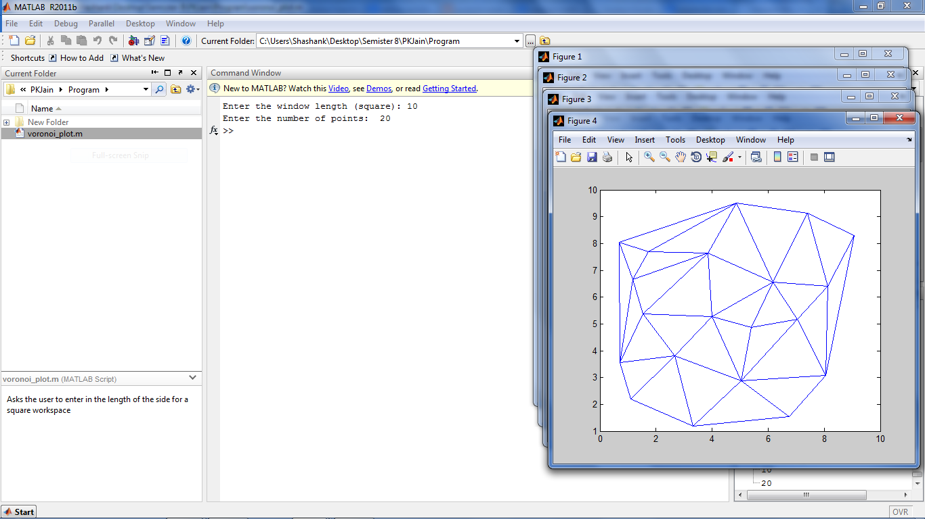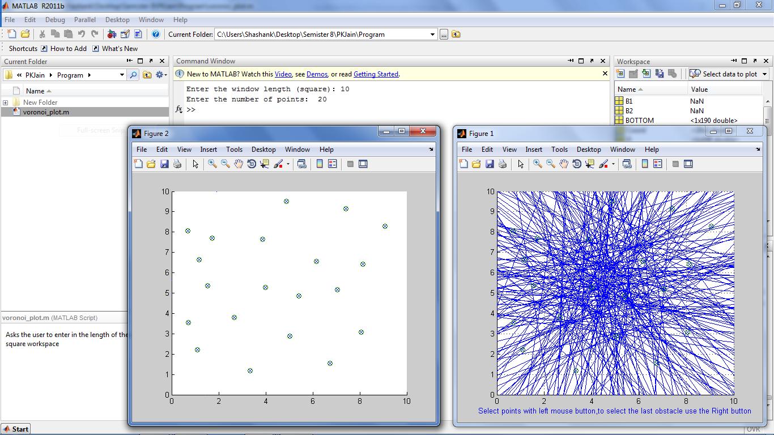 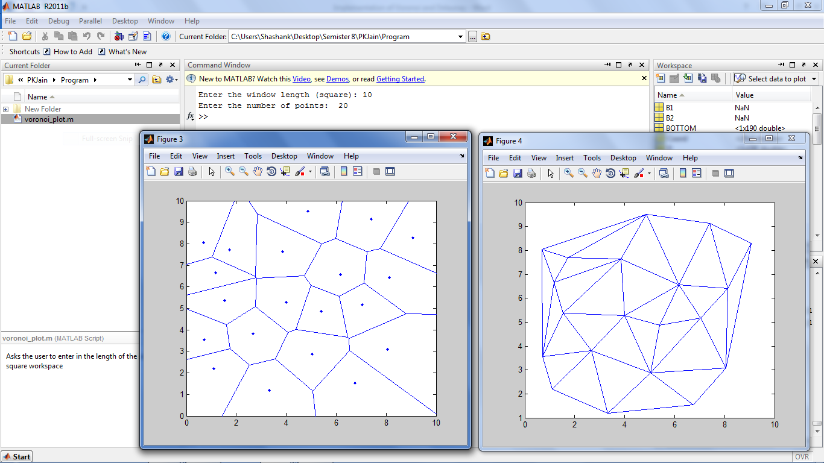

Delaunay Triangulation

Voronoi Diagram

Input point Data

Visualisation of Step 2: Perpendicular Bisectors

Input entered by user